**Q 1 Java program to print welcome message.**

**package** classprog;

**public** **class** Welcome {

**public** **static** **void** main(String[] args) {

System.***out***.println("welcome");

}

}

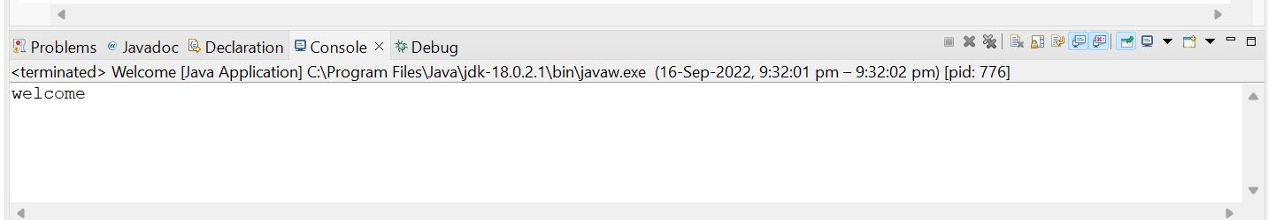

**Q 2 Java program to print sum of  three float numbers**

**public** **class** Floatadd {

**public** **static** **void** main(String[] args) {

**float** a=2.4f,b=3.4f,c=5.4f;

c=a+b;

System.***out***.println("addition of two float numbers=" +c);

}

}

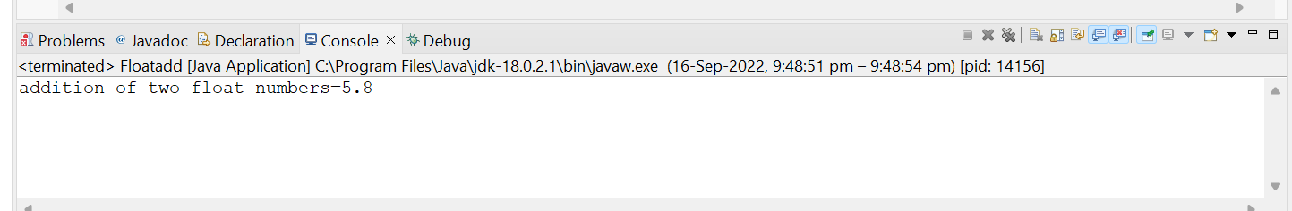

**Q 3 Java Program to Swap Two Numbers**

**package** classprog;

**public** **class** Swapno {

**public** **static** **void** main(String[] args) {

**int** x=20,y=30,z;

System.***out***.println("before swapping x="+x);

System.***out***.println("before swapping y="+y);

z=x;

x=y;

y=z;

System.***out***.println("after swapping x"+x);

System.***out***.println("after swapping y="+y);

}

}

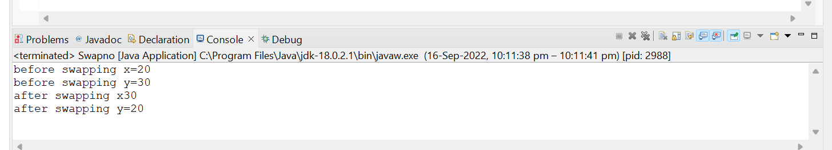

**Q 4 Wap to check if number is even or odd**

**package** classprog;

**import** java.util.Scanner;

**public** **class** Evenodd {

**public** **static** **void** main(String[] args) {

Scanner s = **new** Scanner(System.***in***);

System.***out***.print("Enter a number: ");

**int** num = s.nextInt();

**if**(num % 2 == 0)

System.***out***.println(num + " is even");

**else**

System.***out***.println(num + " is odd");

}

}

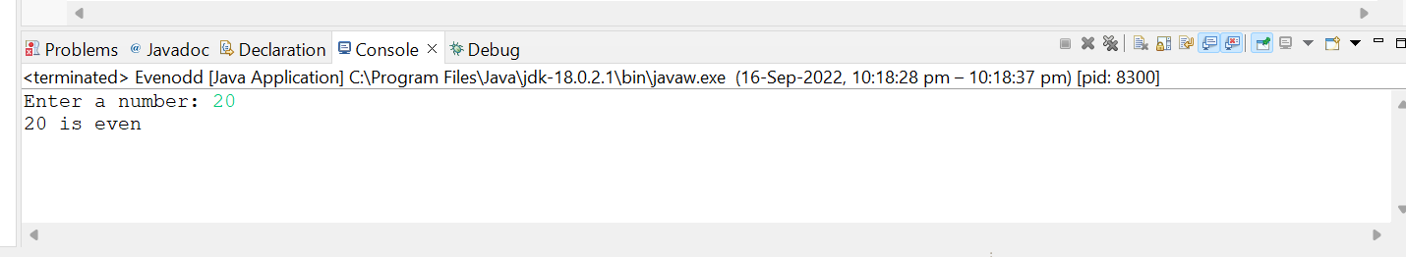

**Q 5 wap to check from three given number  that whether a number is greater than or equal to 20 and less than other numbers .print appropriate message .**

**package** classprog;

**import** java.util.Scanner;

**public** **class** Que5 {

**public** **static** **void** main(String[] args) {

System.***out***.println("Enter 3 number");

Scanner s = **new** Scanner(System.***in***);

System.***out***.print("enter 1st number = ");

**int** a = s.nextInt();

System.***out***.print("enter 2nd number = ");

**int** b = s.nextInt();

System.***out***.print("enter 3rd number = ");

**int** c = s.nextInt();

System.***out***.println("a = " +a +",b = " +b + ", c = " +c);

**if**(a>20 && (a<b && a<c)) {

System.***out***.println("Condition is true because a is greater then 20 and less then b and c");

}

**else**

System.***out***.print("Condition is false");

}

}

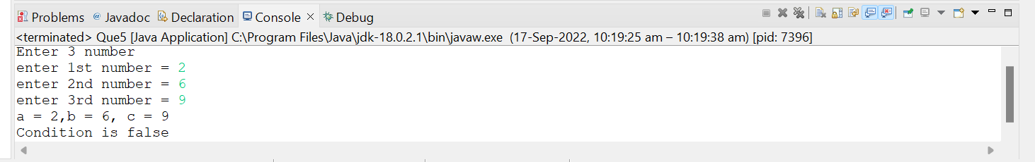

**Q 7 wap to check if sales of a person is greater than 10000 then eligible for bonus   
else not eligible calculate bonus as 20% of sales .**

**package** classprog;

**import** java.util.Scanner;13

**public** **class** Bonus {

**public** **static** **void** main(String[] args) {

Scanner s = **new** Scanner(System.***in***);

System.***out***.print("Enter your Sales Amount = ");

**int** sales = s.nextInt();

**if**(sales>10000) {

System.***out***.print("Eligible for bonus ,");

Float bonus = (sales*20)/100f ;

System.***out***.println("Your bonus amount is " +bonus);

}

**else**

System.***out***.println("Not Eligible for bonus ");

}

}

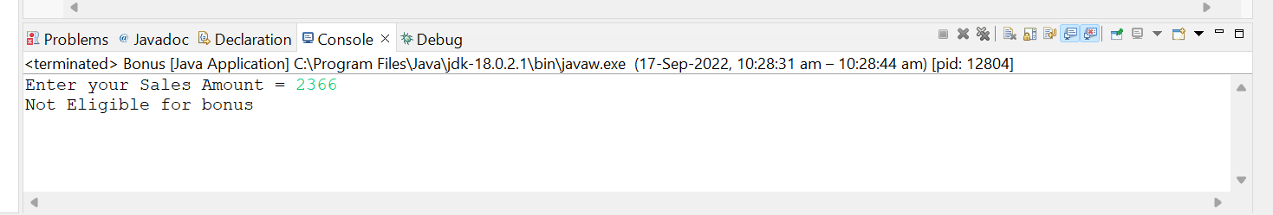

**Q 8 wap to check if two given integer value is in range of 18 and 100 print eligible for voting else not eligible .**

**package** classprog;

**import** java.util.Scanner;

**public** **class** Voting {

**public** **static** **void** main(String[] args) {

Scanner s = **new** Scanner(System.***in***);

System.***out***.print("enter your age = ");

**int** a= s.nextInt();

**if**(a>18 && a<100)

System.***out***.print("you are Eligible for voting");

**else**

System.***out***.print("you are Not Eligible for voting" );

}

}

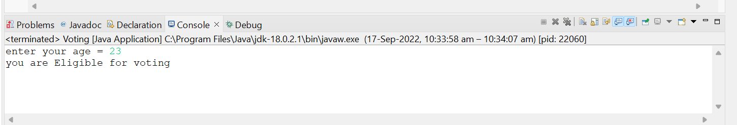

**Q 9 wap to print average of  given five subjects marks of student and check if average >=40 print Pass else print fail**

**package** classprog;

**import** java.util.*;

**public** **class** Studavg {

**public** **static** **void** main(String[] args) {

Scanner s = **new** Scanner(System.***in***);

System.***out***.print("Enter you 5 Subject marks = ");

**int** a=s.nextInt();

**int** b=s.nextInt();

**int** c=s.nextInt();

**int** d=s.nextInt();

**int** e=s.nextInt();

**float** g = (a+b+c+d+e)/5f;

System.***out***.println("Your avg marks is = " +g);

**if**(g>40)

System.***out***.println("you are pass");

**else**

System.***out***.print("you are fail");

}

}

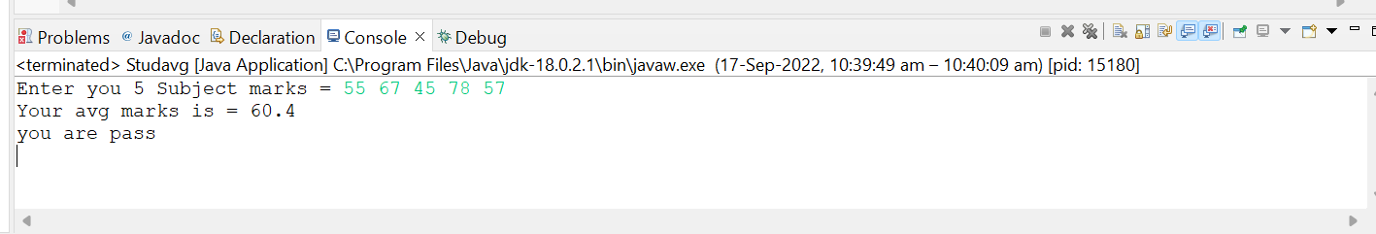

**Q10 WAP to ask name ,age and salary of an employee and print on console.**

**package** classprog;

**import** java.util.Scanner;

**public** **class** Empinfo {

**public** **static** **void** main(String[] args) {

**int** age;

String name;

**int** sal;

Scanner s = **new** Scanner(System.***in***);

System.***out***.println("Enter the age, name and Salary of teh employee");

age=s.nextInt();

name=s.next();

sal=s.nextInt();

System.***out***.println("name"+name);

System.***out***.println("age"+age);

System.***out***.println("salary"+sal);

}

}

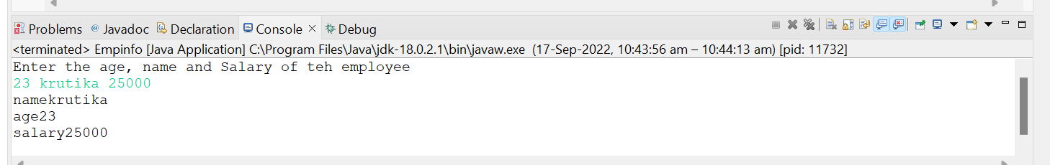

**Q 11 wap  that ask two numbers from user and print greater number among two**

**package** classprog;

**import** java.util.*;

**public** **class** Greaterno {

**public** **static** **void** main(String[] args) {

Scanner s= **new** Scanner (System.***in***);

System.***out***.print("Enter 1st number = ");

**int** a=s.nextInt();

System.***out***.print("Enter 2nd number = ");

**int** b=s.nextInt();

**if**(a>b)

System.***out***.print("1st number is greater");

**else**

System.***out***.print("2nd number is greater");

}

}

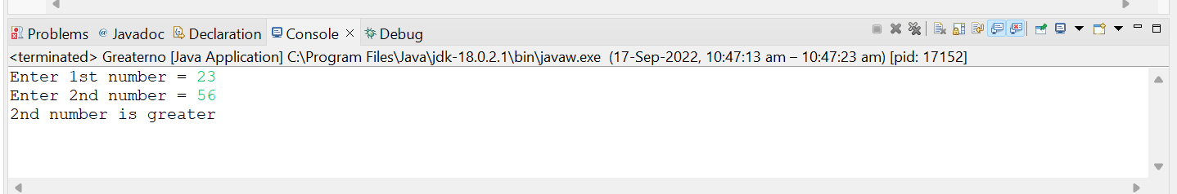

**Q 12  wap to ask product name and price of product from user and calculate discount i.e   
if price > 2000 then discount is 10 percent of price   
else discount is 7 % of price**

**package** classprog;

**import** java.util.*;

**public** **class** Discount {

**public** **static** **void** main(String[] args) {

Scanner s = **new** Scanner(System.***in***);

System.***out***.print("Enter your product name =");

String a =s.nextLine();

System.***out***.println("Enter your product price =");

**int** b=s.nextInt();

**if**(b>2000) {

Float c = (b*10)/100f;

System.***out***.println("you discount is 10%, Total amount = " +c);

}

**else** {

Float d = (b*7)/100f;

System.***out***.println("your discount is 7%, Total amount = " +d);

}

}

}

